Experiment no-1
Library Management System
AIM:
To develop a library management website using HTML, CSS, and JavaScript to manage books and student records. The system allows users to search books, track issued and returned books, and calculate fines.
PROCEDURE:
- Create an HTML page for book search and login.
- Use CSS to design the webpage.
- Use JavaScript to search books and display results.
- Add admin and student modules.
- Run the application in a web browser.
Sample Code:
<!DOCTYPE html>
<html>
<body>
<h2>Library Management System</h2>
<input id="book" placeholder="Enter book name">
<button onclick="searchBook()">Search</button>
<p id="result"></p>

<script>
function searchBook() {
let b = document.getElementById("book").value;
let books = ["Java", "Python", "HTML"];

if (books.includes(b)) {
document.getElementById("result").innerHTML =
b + " book is available";
} else {
document.getElementById("result").innerHTML =
"Book not found";
}}</script>
</body>
</html>
Sample Output:
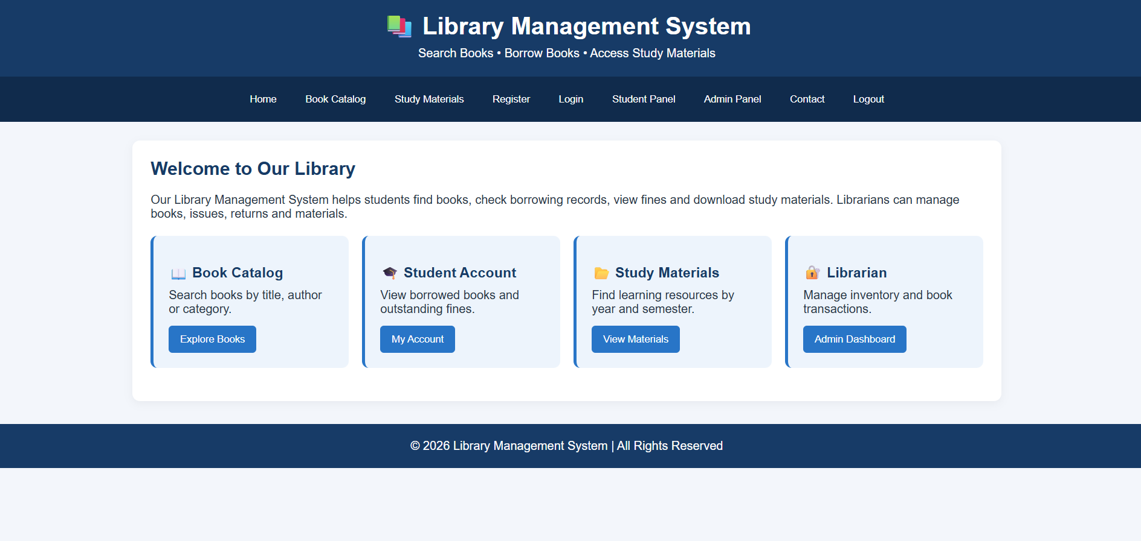
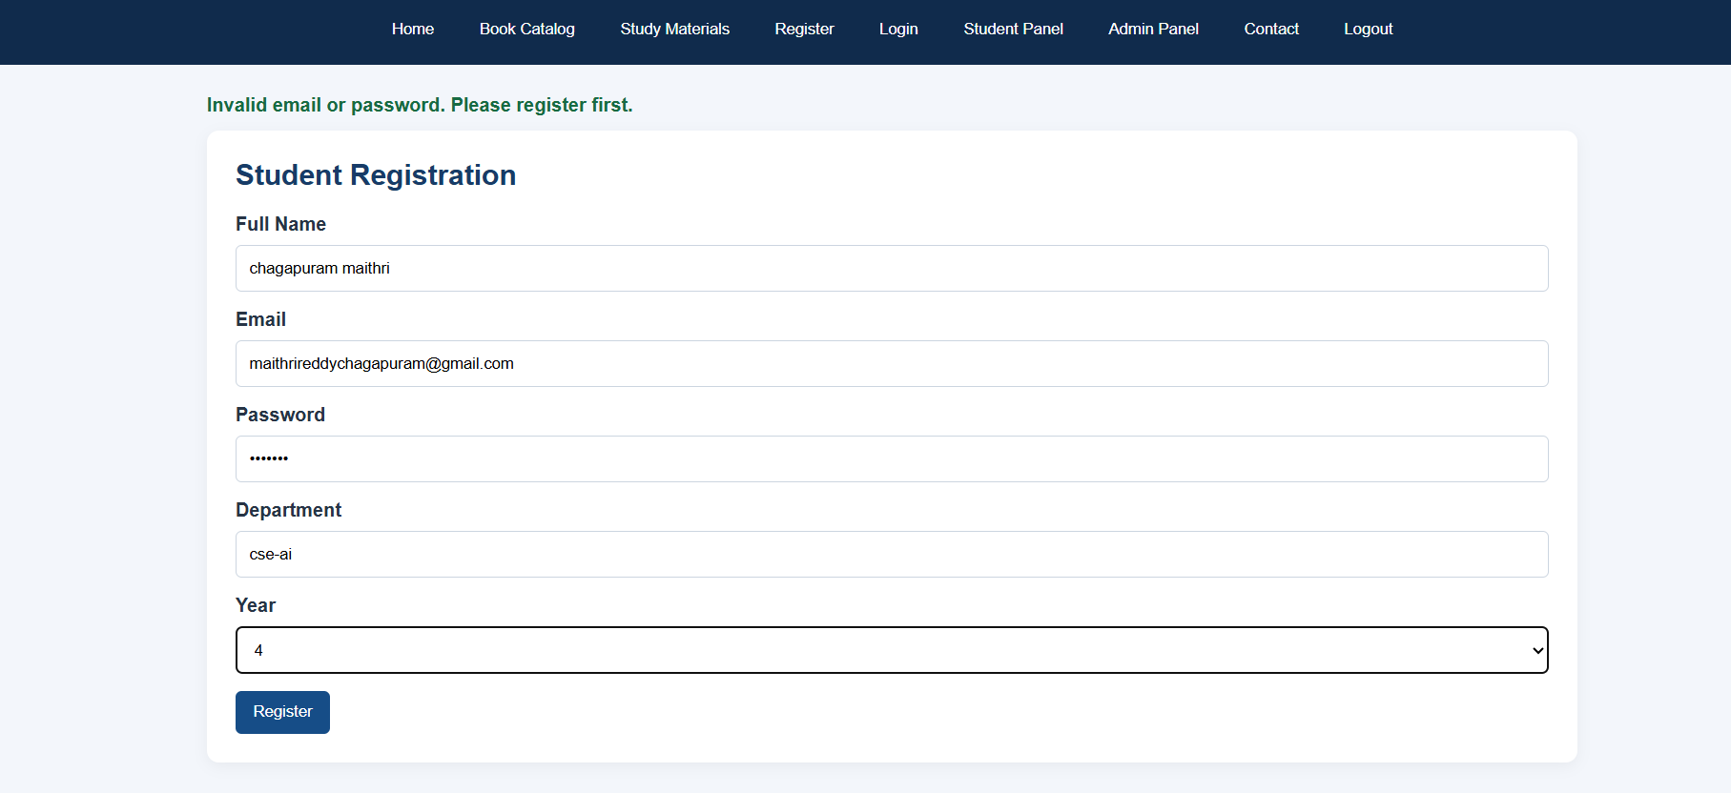
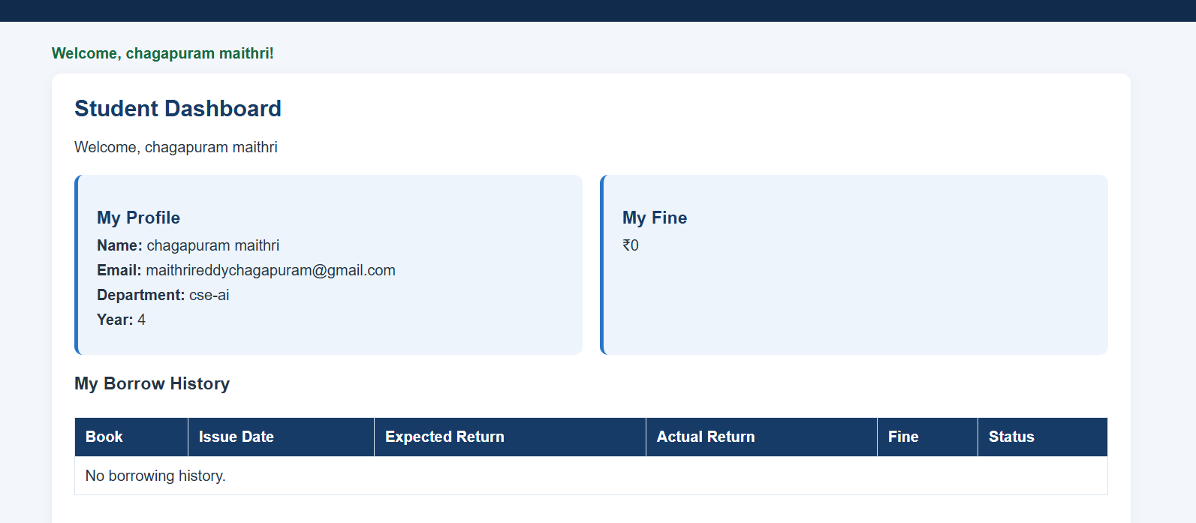
Result:
Thus, the library management website was developed successfully to search books, manage book records, track issue and return status, and calculate fines.

